**1)**

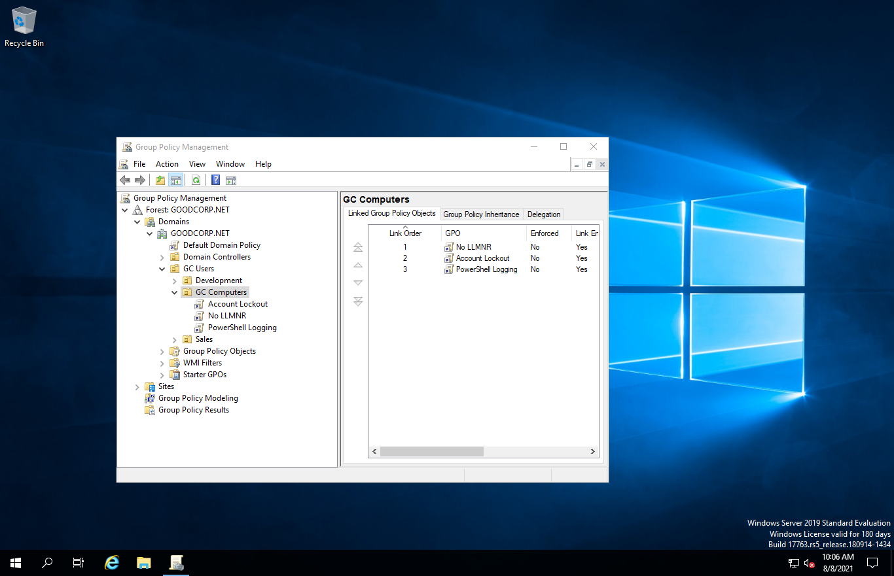

**2)**

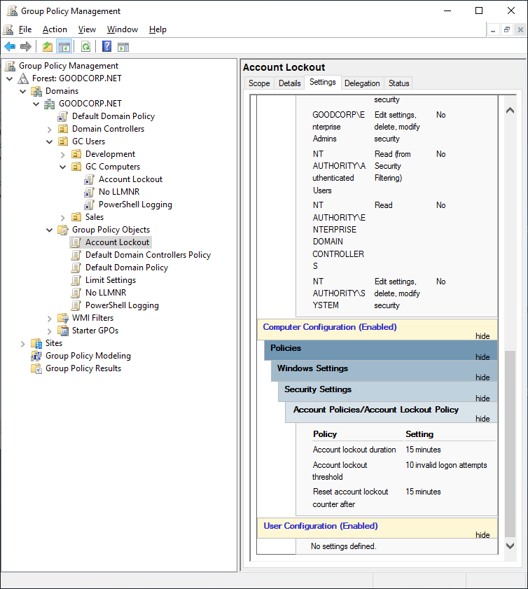

**3)**

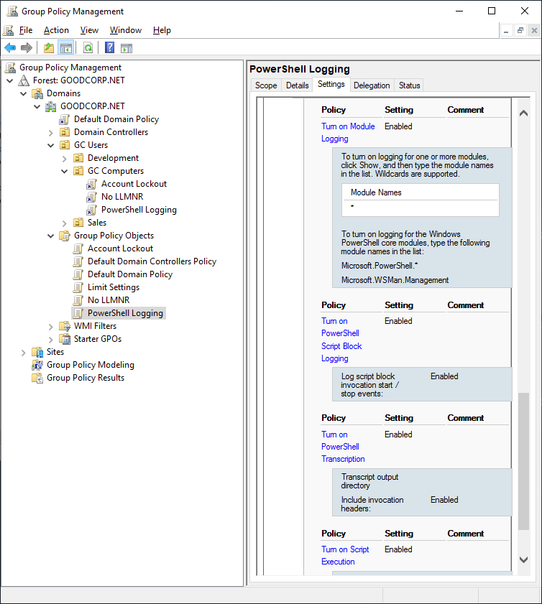

**4) Contents of enum_acls.ps1 script:**

$directory = "./"

$item = "*"

foreach ($item in $directory) {

Get-Acl *

}

**5) Debugging…… logs not being produced…. Running Powershell in server environment, seems rules did not apply server side. Log was created when enum_acls.ps1 was run in windows 10. See screen cap:**

